**Assignment 5**

**U21546216**

**Scott Bebington**

**Task 1**

* 1. C
  2. A
  3. D
  4. C
  5. B

**Task 2**

2.1)

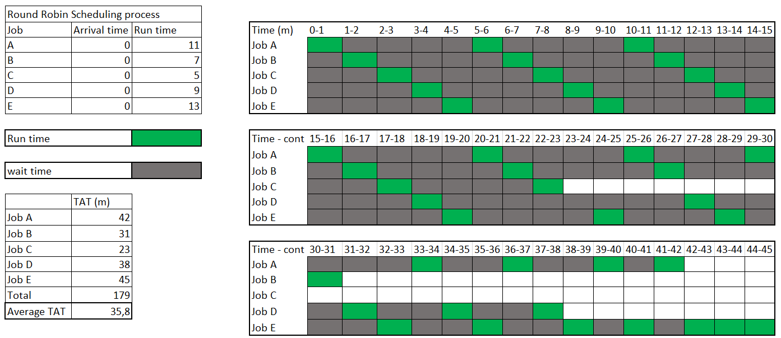

Average TAT = (42 + 31 + 23 + 38 + 45)/5 = 35.8 mins

2.2)

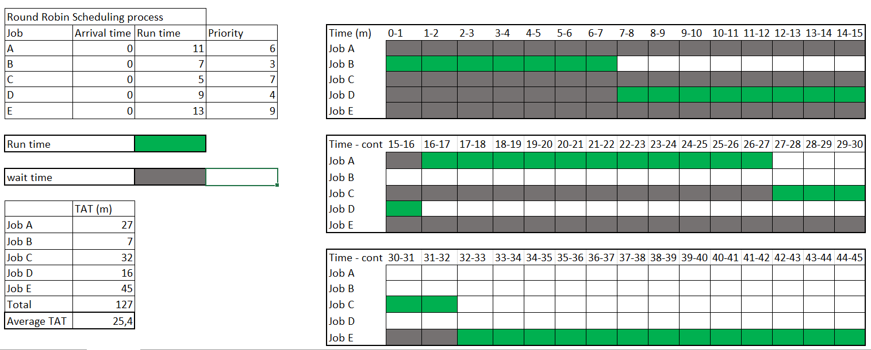

Average TAT = (27 + 7 + 32 + 16 + 45) / 5 = 25.4 min

2.3)

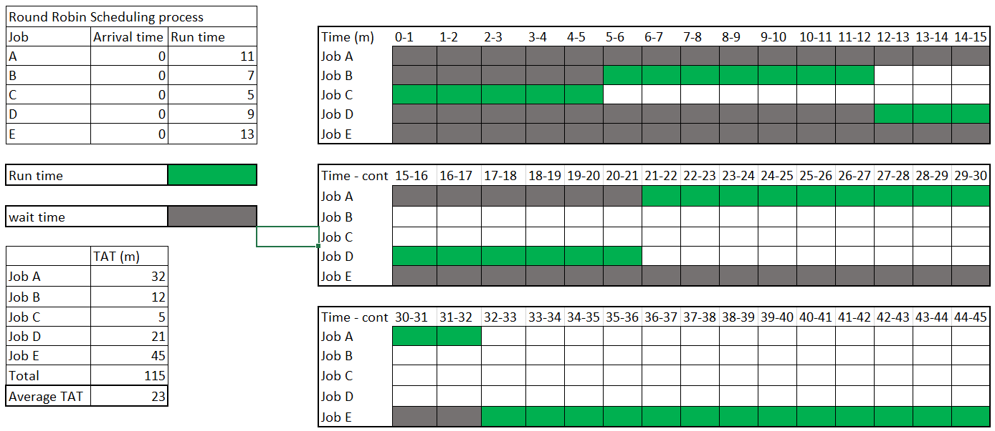

Average TAT = (32 + 12 + 5 + 21 + 45) / 5 = 23mins

**Task 3**

3.1) 4.8 milliseconds

3.2) 2.4 milliseconds

**Task 4**

4.1)

FIFO – First In First Out

Tracks in order: 1000, 740, 1150, 940, 1200, 1850, 1145, 555, 1775, 1695

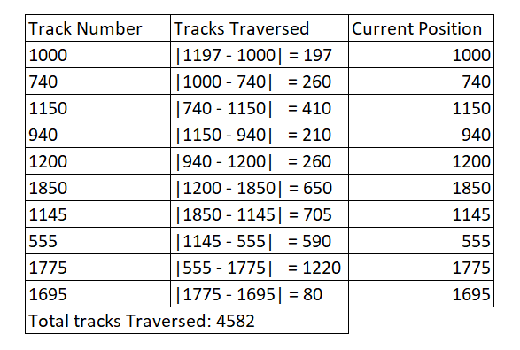

4.2)

SSTF – Shortest Service Time First

Tracks in order: 1200, 1150, 1145, 1000, 940, 740, 555, 1695, 1775, 1850

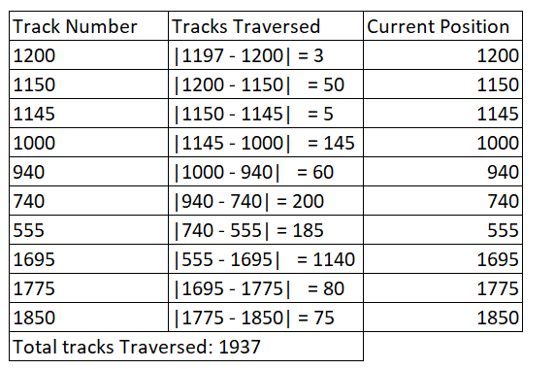

4.3)

SCAN

Tracks in order: 1200, 1695, 1775, 1850, 1150, 1145, 1000, 940, 740, 555

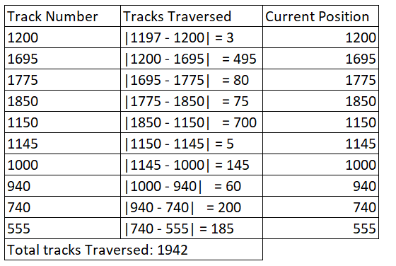

4.4)

C – SCAN

Tracks in order: 1200, 1695, 1775, 1850, 555, 740, 940, 1000, 1145, 1150

